**Resort Management System**

Based on the following tables, write queries to get the results what we are looking for.

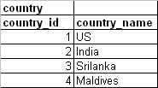

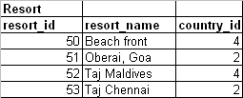

|  |  |  |  |
| --- | --- | --- | --- |
| **customer** |  |  |  |
| **cust_id** | **cust_name** | **phone** | **country_id** |
| 1001 | Tim Downey | 123456789 | 1 |
| 1002 | Ramesh K | 596869689 | 2 |
| 1003 | Bill Price | 74849498 | 1 |
| 1004 | Malinga | 83733938 | 3 |
| 1005 | Farooq | 8958498 | 4 |

1. Query to find out country wise resort count.
2. Query to display country wise customer count.
3. Display countries in which we don’t have any resorts.
4. Display countries in which we have minimum of 100 customers.
5. Display how many resorts we have in the country where resort ‘Beach front’ is
6. Display customers whose name starts with F or R and who are either from India or Srilanka.
7. Display customer names who are from US and do not have any phone numbers.
8. Display Country name, resort name. Display all the countries in the list whether we have resorts or not.
9. Display country wise resort count as level 1,2,3

Level 1 ->=2 resort

Level2 >=1 resort

Leve3 = 0

10.Display resort name belongs to US and INDIA

**FIRST WRITE QUERY IN A BOOK WITHOUT USING SQL DEVELOPER LATER CHECK IN SQL DEVELOPER**

Table access

----------------------------

create table country as select * from team9_shobha.country

create table resort as select * from team9_shobha.resort

create table customer as select * from team9_shobha.customer1